**More CSS Properties**

1. **Background**

Source: <https://www.w3schools.com/css/css_background.asp> & <https://www.w3schools.com/css/css3_backgrounds.asp>

background is a shorthand

{ background: <color> <image> <repeat> <attachment> <position>/<size> <origin> <clip> }

Example:

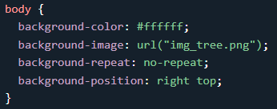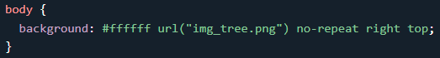

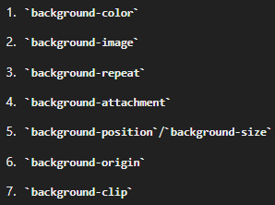Note: <position>/<size> harus berurutan, selain itu bebas.

Urutan konvensional(optional):

1. Color

{ background-color: ; } & { opacity: ; (opsional) }

1. Image

{ background-image: url(…) }

1. Repeat

{ background-repeat: repeat-x/repeat-y/no-repeat }

By default, the background-image property repeats an image both horizontally and vertically.

Some images should be repeated only horizontally or vertically, or they will look strange.

1. Attachment

{ background-attachment: scroll/fixed }

specifies whether the background image should scroll or be fixed.

1. Position

{ background-position: right top }

specify the position of the background image.

1. Size

{ background-size: length/percentage/contain or cover }

- contain: Mempertahankan aspek rasio. Namun jika aspek rasio background tidak sama dg elemen, maka background mungkin tidak akan menutupi seluruh elemen, sehingga dapat terlihat ruang kosong di sekitar gambar.

- cover: Mempertahankan aspek rasio. Namun jika aspek rasio background tidak sama dg elemen, maka background dicrop, tetapi tidak akan ada ruang kosong yang terlihat.

1. Origin

{ background-origin: border-box/padding-box/content-box }

specifies where the background image starts positioned.

1. Clip

{ background-clip: border-box/padding-box/content-box }

specifies the painting area of the background.

Note: Multiple backgrounds through the 'background-image' separated by commas, and the images are stacked on top of each other, where the first image is closest to the viewer.

1. Borders

> border: *size style color*;

> border radius: *value*;

1. Box-shadow

{ box-shadow: *h-offset v-offset blur spread color*; }

Adds a shadow effect around an element.

1. Overflow

{ overflow/overflow-x/overflow-y: visible/hidden/scroll/auto }

Define what happens to an element when its content is too big to fit.

1. Opacity

{ opacity/rgba/hsla }

specifies the opacity/transparency of an element.

value: 0.0 - 1.0